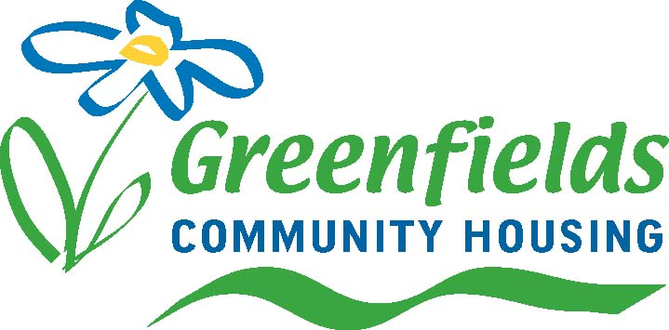

GREENFIELDS COMMUNITY HOUSING
PROCUREMENT SERVICES

Name of Project

Tender Reference GREEN/XXXX

ANNEX B – ENVIRONMENTAL SYSTEMS QUESTIONS

 | QUESTION | RESPONSE
1 | Does YOUR COMPANY have an environmental policy, green policy or environmental management policy, Sustainable Procurement Policy?  If YES –  (i) has it been approved at Board level?  (ii) does it meet the requirements of ISO14000,  EMAS or equivalent  (iii) please provide copies and full details
2.1  2.2  2.3  2.4 | Does YOUR COMPANY operate an environmental management system?  If NO, please go to Question 4  If YES, does the system meet the requirements of ISO 14000, EMAS or equivalent?  If YES, is the system certified by an accredited body under ISO 14000, EMAS or equivalent?  If YES, please give precise details of the firm’s certification including:  (i) Name of certification body  (ii) Extent of certification (including the parts of  the company and the function covered by the  certification)  (iii) Date of certification  (iv) Certification number  (v) Date and extent of last environmental audit  If you have answered YES to Questions 2.1, 2.2, 2.3 and provided the details requested in Question 2.4, please proceed to Question 10 and answer all subsequent questions.  If you have answered YES to Questions 2.1 and 2.2 but NO to Questions 2.3, please proceed to Question 3 and answer all subsequent questions.
3 | Please supply full documentary evidence of the company’s environmental management system
4 | Has your company produced an environmental review? If YES, please provide details.
5 | Has YOUR COMPANY developed an environmental programme?  If YES, please provide details.
6 | Has an environmental audit been carried out?  If YES, please provide details.
7 | Has YOUR COMPANY identified responsibilities and reporting structures for environmental matters?  If YES, please provide details.
8 | Has and environmental statement been produced?  If YES, please provide details.
9 | If YOUR COMPANY has not achieved, or is not actively seeking external accreditation for Environmental Management, please indicate, supplying appropriate evidence, what other system the company operates to ensure proper control of processes and procedures which may have an impact on the environment.
10 | What experience does YOUR COMPANY have of purchasing environmentally sensitive materials in connection with this or any other type of contract?  Please supply full details.
11 | What experience does YOUR COMPANY have of waste minimisation, material recycling or energy efficiency schemes in connection with this type of contract?  Please supply full details.
12 | Has YOUR COMPANY been prosecuted, or been issued with a statutory nuisance abatement notice, default/warning notices, improvement notice or other enforcement notice or order, by any local authority, the Environment Agency (formally HMIP & NRA) or any other enforcement body responsible for environmental protection (including a Planning Authority in respect of any breach of planning control)?  If YES, please provide full details, including action taken by the company in response.
13 | Has YOUR COMPANY supported local or environmental improvements?  If YES, please provide full details.
14 | What measures DO YOUR COMPANY take to minimise and control emissions to atmosphere, land and water?
15 | What measures DO YOUR COMPANY take to minimise the use of water?
16 | Does YOUR COMPANY have an established programme for the training of staff on environmental issues?  If YES, please provide full details

